**Consider the schema for Movie Database: ACTOR (Act_id, Act_Name, Act_Gender) DIRECTOR (Dir_id, Dir_Name, Dir_Phone)**

**MOVIES (Mov_id, Mov_Title, Mov_Year, Mov_Lang, Dir_id) MOVIE_CAST (Act_id, Mov_id, Role)**

**RATING (Mov_id, Rev_Stars) Write SQL queries to**

* 1. **List the titles of all movies directed by**
  2. **Find the movie names where one or more actors acted in two or more movies.**
  3. **List all actors who acted in a movie before 2000 and also in a movie after 2015 (use JOIN operation).**
  4. **Find the title of movies and number of stars for each movie that has at least one rating and find the highest number of stars that movie received. Sort the result by movie title.**

**5. ** **5.**

**Program Objectives:**

**This course will enable students to**

Foundation knowledge in database concepts, technology and practice to groom students into well-informed database application developers.

Strong practice in SQL programming through a variety of database problems. Develop database applications using front-end tools and back-end DBMS.

**Solution:**

**Entity-Relationship Diagram**

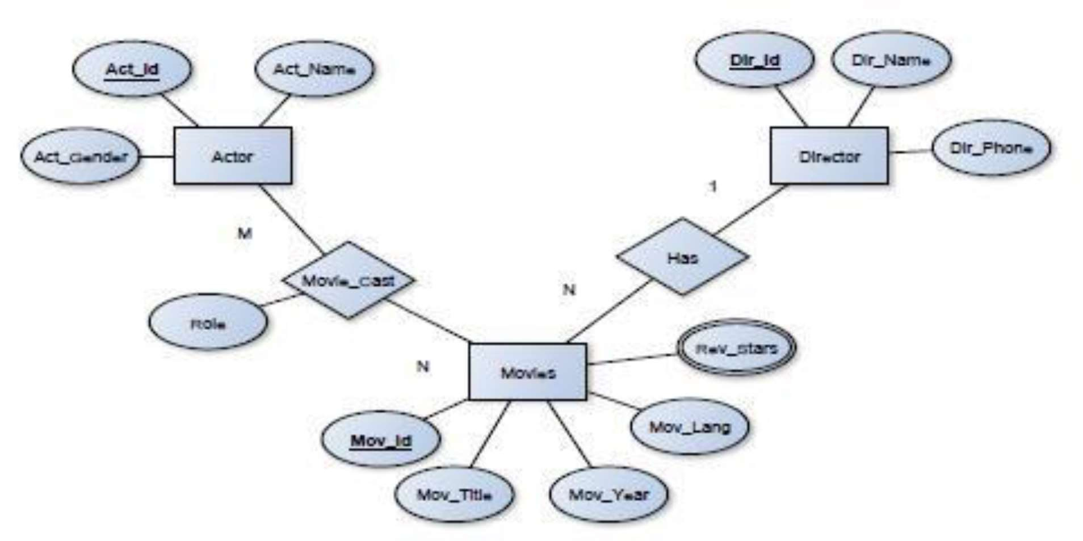

**Schema Diagram**

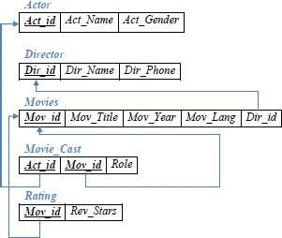

**Table Creation**

CREATE TABLE ACTOR ( ACT_ID INT (5) PRIMARY KEY, ACT_NAME VARCHAR (20),

ACT_GENDER CHAR (1));

CREATE TABLE DIRECTOR ( DIR_ID INT (5) PRIMARY KEY, DIR_NAME VARCHAR (20), DIR_PHONE BIGINT);

CREATE TABLE MOVIES (MOV_ID INT (4) PRIMARY KEY, MOV_TITLE VARCHAR (50),

MOV_YEAR INT (4),

MOV_LANG VARCHAR (20),

DIR_ID INT (5),

FOREIGN KEY (DIR_ID) REFERENCES DIRECTOR(DIR_ID));

CREATE TABLE MOVIES_CAST ( ACT_ID INT (5),

MOV_ID INT (5),

ROLE VARCHAR (20),

PRIMARY KEY (ACT_ID, MOV_ID),

FOREIGN KEY (ACT_ID) REFERENCES ACTOR (ACT_ID), FOREIGN KEY (MOV_ID) REFERENCES MOVIES (MOV_ID));

CREATE TABLE RATING ( MOV_ID INT (5) PRIMARY KEY, REV_STARS VARCHAR (25),

FOREIGN KEY (MOV_ID) REFERENCES MOVIES (MOV_ID));

#### Table Descriptions

DESC ACTOR;

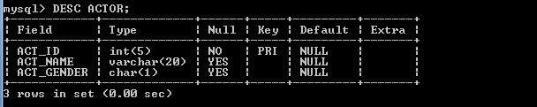

DESC DIRECTOR;

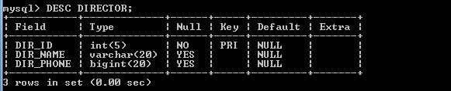

DESC MOVIES;

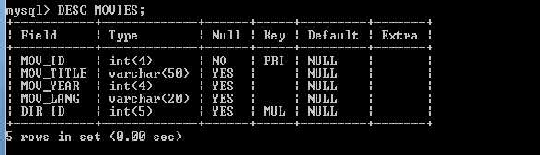

DESC MOVIES_CAST;

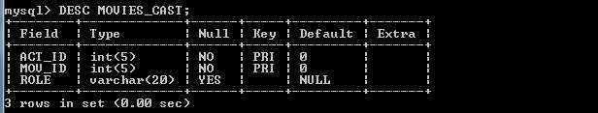

DESC RATING;

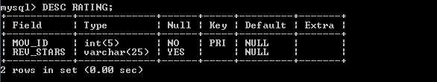

#### Insertion of Values to Tables

INSERT INTO ACTOR VALUES (  INSERT INTO ACTOR VALUES ( INSERT INTO ACTOR VALUES ( INSERT INTO ACTOR VALUES (

 9563400156); INSERT INTO DIRECTOR VALUES(102,'ALAN TAYLOR',9971960035);

75); INSERT INTO DIRECTOR VALUES (105,'HITCHCOCK',7766138911); INSERT INTO DIRECTOR VALUES (106,'STEVEN SPIELBERG',9966138934);

25);

INSERT INTO MOVIES VALUES (501,'JAB HARRY MET SEJAL',2017,'HINDI',104); INSERT INTO MOVIES VALUES (502,'RAJAKUMARA',2017,'KANNADA',103); INSERT INTO MOVIES VALUES (503,'JOLLY LLB 2', 2013,'HINDI', 100);

INSERT INTO MOVIES VALUES (504,'TERMINATOR GENESYS',2015,'ENGLISH',102); INSERT INTO MOVIES VALUES (505,'JAWS',1975,'ENGLISH',106);

INSERT INTO MOVIES VALUES (506,'BRIDGE OF SPIES',2015,'ENGLISH', 106); INSERT INTO MOVIES VALUES (507,'VERTIGO',1943,'ENGLISH',105);

INSERT IN



INSERT INTO MOVIES_CAST VALUES (1, 501,'HEROINE'); INSERT INTO MOVIES_CAST VALUES (1, 502,'HEROINE'); INSERT INTO MOVIES_CAST VALUES (3, 503,'COMEDIAN'); INSERT INTO MOVIES_CAST VALUES (4, 504,'GUEST'); INSERT INTO MOVIES_CAST VALUES (4, 501,'HERO');

INSERT INTO RATING VALUES (501, 4);

INSERT INTO RATING VALUES (502, 2);

INSERT INTO RATING VALUES (503, 5);

INSERT INTO RATING VALUES (504, 4);

INSERT INTO RATING VALUES (505, 3);

INSERT INTO RATING VALUES (506, 2);

SELECT * FROM ACTOR;

|  |  |  |
| --- | --- | --- |
| **ACT_ID** | **ACT_NAME** | **ACT** |
| 1 | MADHURI DIXIT | F |
| 2 | AAMIR KHAN | M |
| 3 | JUHI CHAWLA | F |
| 4 | SRIDEVI | F |

SELECT * FROM DIRECTOR;

|  |  |  |
| --- | --- | --- |
| **DIR_ID** | **DIR_NAME** | **DIR_PHONE** |
| 100 | SUBHASH KAPOOR | 56340015 |
| 102 | ALAN TAYLOR | 719600310 |
| 103 | SANTHOSH ANANDDRAM | 99346111 |
| 104 | IMTIAZ ALI | 85399209 |
| 105 | HITCHCOCK | 7766138911 |
| 106 | STEVEN SPIELBERG | 9966138934 |

SELECT * FROM MOVIES;

|  |  |  |  |  |
| --- | --- | --- | --- | --- |
| **MOV_ID** | **MOV_TITLE** | **MOV_YEAR** | **MOV_LANG** | **DIR_ID** |
| 501 | JAB HARRY MET SEJAL | 2017 | HINDI | 104 |
| 502 | RAJAKUMARA | 2017 | KANNADA | 103 |
| 503 | JOLLY LLB 2 | 2013 | HINDI | 100 |
| 504 | TERMINATOR GENESYS | 2015 | ENGLISH | 102 |
| 505 | JAWS | 1975 | ENGLISH | 106 |
| 506 | BRIDGE OF SPIES | 2015 | ENGLISH | 106 |
| 507 | VERTIGO | 1958 | ENGLISH | 105 |
| 508 | SHADOW OF A DOUBT | 1943 | ENGLISH | 105 |

SELECT * FROM MOVIE_CAST;

|  |  |  |  |  |
| --- | --- | --- | --- | --- |
| **MOV_ID** | **MOV_TITLE** | **MOV_YEAR** | **MOV_LANG** | **DIR_ID** |
| 501 | JAB HARRY MET SEJAL | 2017 | HINDI | 104 |
| 502 | RAJAKUMARA | 2017 | KANNADA | 103 |
| 503 | JOLLY LLB 2 | 2013 | HINDI | 100 |
| 504 | TERMINATOR GENESYS | 2015 | ENGLISH | 102 |
| 505 | JAWS | 1975 | ENGLISH | 106 |
| 506 | BRIDGE OF SPIES | 2015 | ENGLISH | 106 |
| 507 | VERTIGO | 1958 | ENGLISH | 105 |
| 508 | SHADOW OF A DOUBT | 1943 | ENGLISH | 105 |

SELECT * FROM RATING;

|  |  |
| --- | --- |
| **MOV_ID** | **REV_STARS** |
| 501 | 4 |
| 502 | 2 |
| 503 | 5 |
| 504 | 4 |
| 505 | 3 |
| 506 | 2 |
| 507 | 2 |
| 508 | 4 |

#### Queries:

1. **List the titles of all movies directed by**

SELECT MOV_TITLE FROM MOVIES WHERE DIR_ID IN (SELECT DIR_ID FROM



### OR

SELECT MOV_TITLE FROM MOVIES M, DIRECTOR D WHERE M.DIR_ID=D.DIR_ID AND DIR_NAME='HITCHCOCK';



#### Find the movie names where one or more actors acted in two or more movies.

SELECT MOV_TITLE FROM MOVIES M,MOVIES_CAST MV

WHERE M.MOV_ID=MV.MOV_ID AND ACT_ID IN(SELECT ACT_ID FROM MOVIES_CAST GROUP BY ACT_ID HAVING COUNT(ACT_ID)>1) GROUP BY MOV_TITLE HAVING COUNT(*)>1;



#### List all actors who acted in a movie before 2000 and also in a movie after 2015 (use JOIN operation).

SELECT ACT_NAME, MOV_TITLE, MOV_YEAR FROM ACTOR A JOIN MOVIE_CAST C ON A.ACT_ID=C.ACT_ID INNER JOIN MOVIES M

ON C.MOV_ID=M.MOV_ID WHERE M.MOV_YEAR NOT BETWEEN 2000 AND 2015;

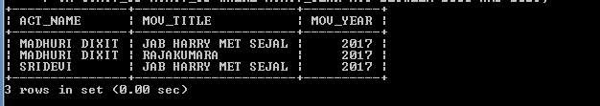

1. **Find the title of movies and number of stars for each movie that has at least one rating and find the highest number of stars that movie received. Sort the result by movie title.** SELECT MOV_TITLE,MAX(REV_STARS) FROM MOVIES M ,RATING R WHERE

M.MOV_ID=R.MOV_ID GROUP BY MOV_TITLE HAVING MAX(REV_STARS)>0 ORDER BY MOV_TITLE;

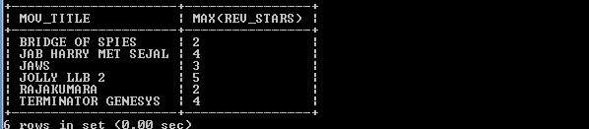

#### 5. 5

UPDATE RATING SET REV_STARS=5 WHERE MOV_ID IN(SELECT MOV_ID FROM MOVIES WHERE DIR_ID IN(SELECT DIR_ID FROM DIRECTOR

WHERE DIR_NAME='STEVEN SPIELBERG'));

### OR

UPDATE RATING R, MOVIES M, DIRECTOR D SET REV_STARS=5 WHERE R.MOV_ID=M.MOV_ID AND M.DIR_ID=D.DIR_ID AND DIR_NAME='STEVEN SPIELBERG';

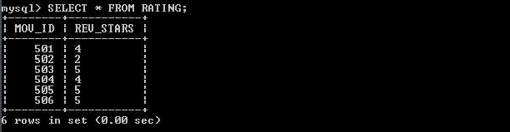

**Program Outcomes:**

**The students are able to**

Create, Update and query on the database.

Demonstrate the working of different concepts of DBMS

Implement, analyze and evaluate the project developed for an application.